

**Artificial intelligence (CSC403)**

**Student name: Razan Abdulrahman Alrashed**

**ID: 443500087**

**Assignment 1**

1

**BFS**

**Using Python Class**

3

2

4

6

5

from collections import defaultdict

class Graph:

    def __init__(self):

        # Default dictionary to store graph.

        self.graph=defaultdict(list)

        # function for adding node and their nighbor

    def add(self,node,nighbor):

        self.graph[node].append(nighbor)

        # function to preform Bredth First Search.

    def BFS(self,start):

        visited=[]

        queue=[]

        visited.append(start)

        queue.append(start)

        while queue:

            m = queue.pop(0)

            print(m, end=" ")

            for neighbor in self.graph[m]:

                if neighbor not in visited:

                    visited.append(neighbor)

                    queue.append(neighbor)

# create a graph instance from graph class.

graph1=Graph()

graph1.add('1','2')

graph1.add('2','3')

graph1.add('2','4')

graph1.add('2','5')

graph1.add('3','6')

# calling BFS function.

graph1.BFS('1')

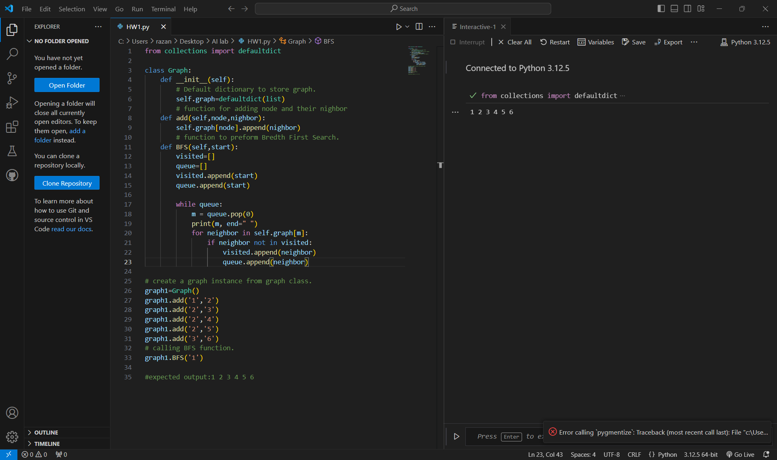#expected output:1 2 3 4 5 6

output 1